Module 4 Linux Essentials   
TASK 4.3

After you have logged into the system, do the following.   
1.Invoke pwd to see your current working directory (there should be your home directory).

  
2. Collect output of these commands   
ls -l /

This command not only shows files and directories in root directory (because there is /), but also provides information about permissions, owner, size, date and time of the last modification, links and format. So, it shows longer version of ls information.

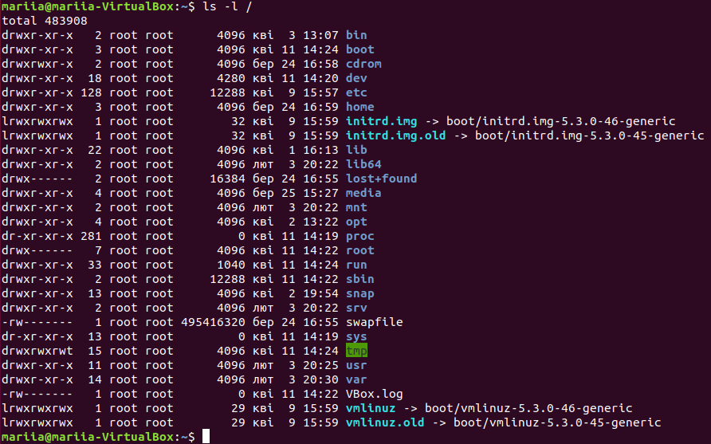  
ls

Shows files and directories in a current directory. In this case this directory is /home/mariia:

ls ~

Shows files and directories in a home directory (even if we are in another directory).

  
ls -l

This command shows longer version of ls information in a current directory.

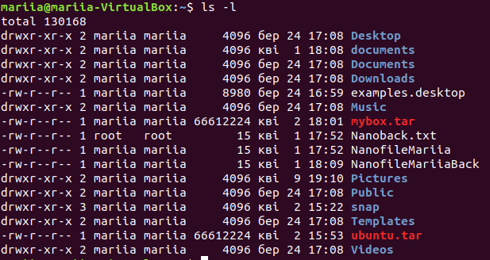  
ls -a

It shows all files and directories in a current directory, even hidden (they are starting with .).

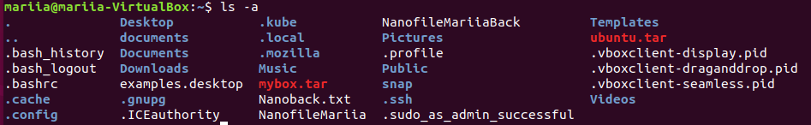  
ls -la

Shows longer version of ls for current directory (with owner, permission, etc) and enables display of hidden files and directories.

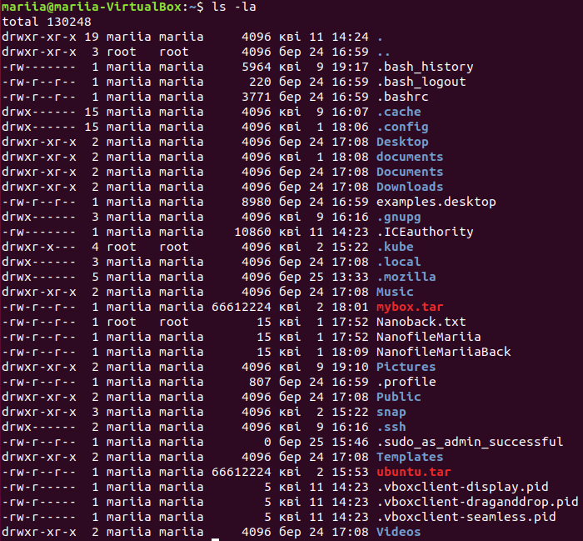  
ls -lda ~

Shows long information (-l) about home directory (~) itself (-d), even if it is hidden(-a).

  
Note differences between produced outputs. Describe (in few words) purposes of these commands.   
3. Execute and describe the following commands (store the output, if any):   
mkdir test   
cd test   
pwd touch test.txt   
ls -l test.txt   
mkdir test2   
mv test.txt test2   
cd test2   
ls mv test.txt test2.txt   
ls cp test2.txt ..   
cd ..   
ls rm test2.txt   
rmdir test2

In a home directory we are creating a new directory test and entering this new directory (mkdir and cd). Then checking, that we are in test folder with the help of pwd. Making a new empty file test.txt in a current directory (touch) and checking full information about this file (ls -l). Then, creating new folder test2 in a current directory (test). After that, we are moving test.txt to the test2 folder, entering test2 and checking that this file test.txt is here now. With the help of mv command, renaming test.txt to test2.txt. As we can see, now in the folder there is only test2.txt file. Next, we can copy test2.txt to the test directory (cp ..), and checking that there is such file there now. Finally, we are removing test2.txt and test2 folder (we can`t do that, because test2.txt is still there).

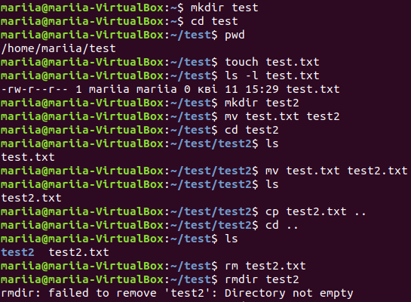

To delete not empty directory rm -r command can be used:



4. Execute and describe the difference   
cat /etc/fstab   
less /etc/fstab   
more /etc/fstab

Less shows one page at a time (navigation though file is possible with page up/down keys) and that is why it can be a little bit faster (it doesn`t load the entire file at once). It also has more functions then more.

More also shows one page at a time, but it loads entire file before that.

Cat outputs the content of the file in the console, it also can show a few files in one output – one by one.

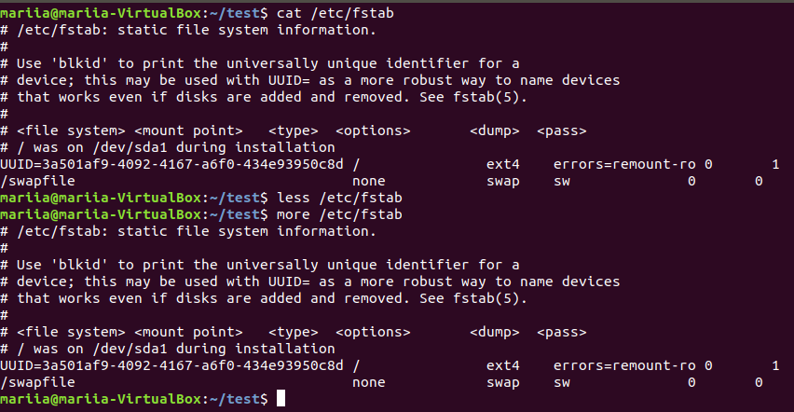

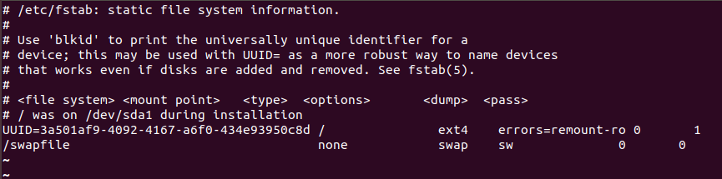

5. Add to archive all ‘test’ directories.

a. to the pure ‘tar’;

b. to the zipped ‘tar’ with only tar command;

c. to the zipped ‘tar’ with gzip command;

extract from archives all above.

tar command helps to add files and folders to archive or to extract them, with or without compression (if with: -z is used). To compress a file, gzip command can be used (and gunzip – to decompress), but it can`t compress a folder. When compression of an archive is needed, it is better to use tar – it is more effective.

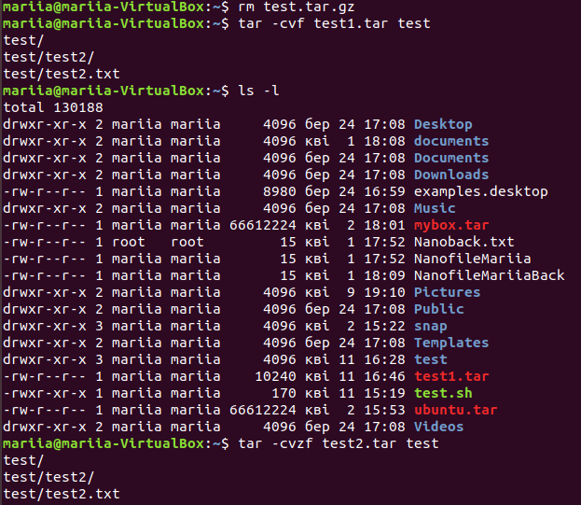

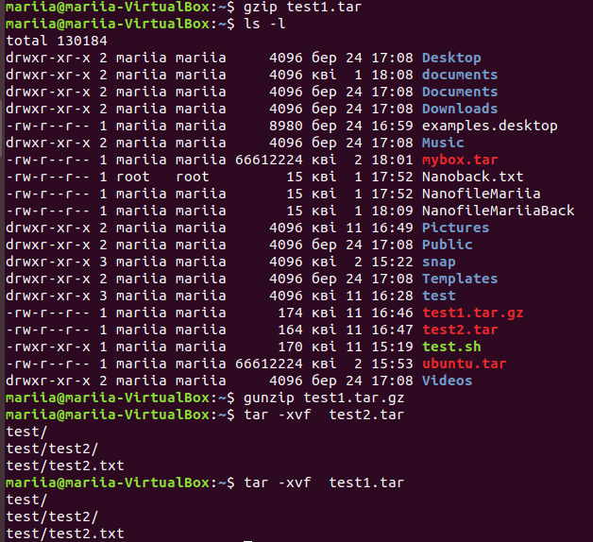

5. Look through man pages of the listed above commands.